**RADISSION HOTEL ANALYSIS**

**Introduction**

**Over View:**

The history of data visualization goes back to prehistoric rock carvings called petroglyphs. Using pictures to tell a story about data is as old as human existence. Data visualization became a profession for map makers in the 1600s. The pie chart first appeared in the early 1800s. Charles Minard took data visualization to a new level in 1869 when he created a ground breaking statistical graphic that mapped Napoleon's 1812-1813 invasion and retreat from Russia.

Data analysis, is a process for obtaining raw data, and subsequently converting it into information useful for decision-making by users. As a data analyst, you can use charts, graphs, maps, and other visual representations of data to help present your findings in an easy-to-understand way. Improving your data visualization skills often means learning visualization software, like Tableau.

**Purpose:**

The purpose of Data Analysis is to extract useful information from data and taking the decision based upon the data analysis. A simple example of Data analysis is whenever we take any decision in our day-to-day life is by thinking about what happened last time or what will happen by choosing that particular decision.

The importance of Data visualization is – analysing complex data, identifying patterns, and extracting valuable insights. Simplifying complex information and presenting it visually enables decision-makers to make informed and effective decisions quickly and accurately. Data analytics helps individuals and organizations make sense of data. Data analysts typically analyse raw data for insights and trends. They use various tools and techniques to help organizations make decisions and succeed.

**Problem Definition & Design Thinking:**

**Result**

=>Dashboard

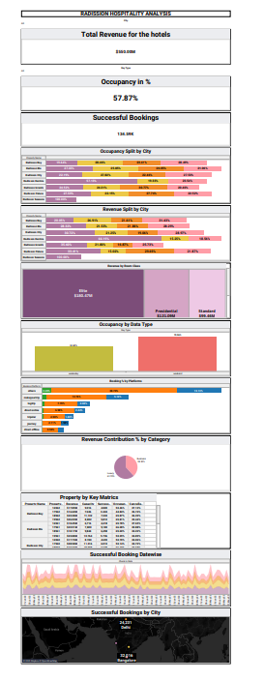

=>Story

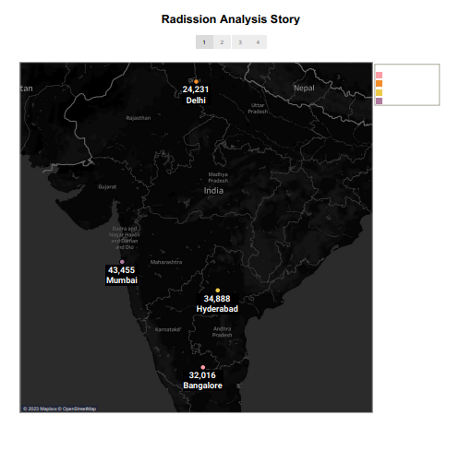

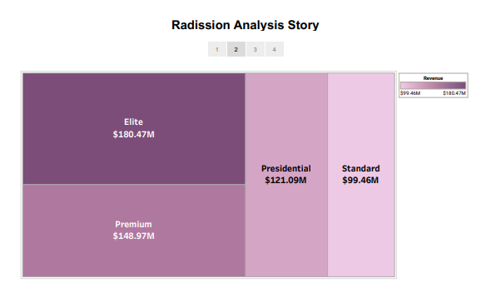

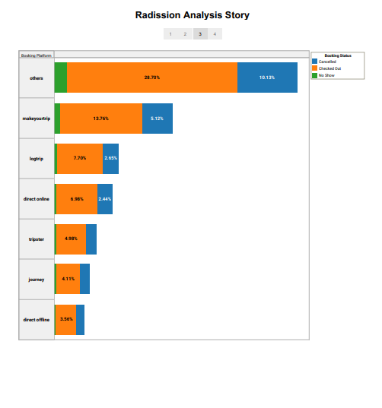

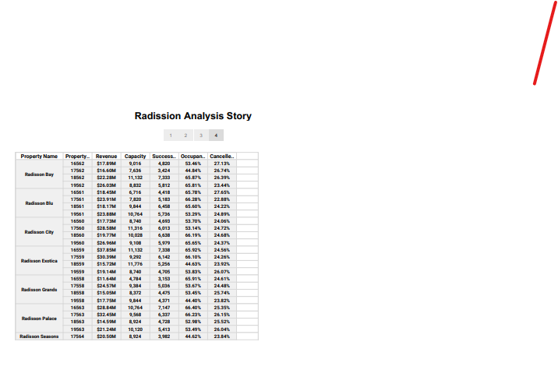

### **Advantages** ➨It detects and correct the errors from data sets with the help of data cleansing. This helps in improving quality of data and consecutively benefits both customers and institutions such as banks, insurance and finance companies. ➨It removes duplicate informations from data sets and hence saves large amount of memory space. This decreases cost to the company. ➨It helps in displaying relevant advertisements on the online shopping websites based on historic data and purchase behaviour of the users. Machine learning algorithms are applied for the same. This helps in increasing revenue and productivity of the companies. ➨It reduces banking risks by identifying probable fraudulent customers based on historic data analysis. This helps institutes in deciding whether to issue loan or credit cards to the applicants or not. ➨It is used by security agencies for surveillance and monitoring purpose based on informations collected by huge number of sensors. This helps in preventing any wrongdoings and/or calamities.

### **Disadvantages** ➨This may breach privacy of the customers as their information such as purchases, online transactions, subscriptions are visible to their parent companies. The companies may exchange these useful customer databases for their mutual benefits. ➨The cost of data analytics tools vary based on applications and features supported. Moreover some of the data analytics tools are complex to use and require training. This increases cost to the company willing to adopt data analytics tools or software. ➨The information obtained using data analytics can also be misused against group of people of certain country or community or caste. ➨It is very difficult to select the right data analytics tools. This is due to the fact that it requires knowledge of the tools and their accuracy in analysing the relevant data as per applications. This increases time and cost to the company.

**Application**

 We know and understand what data analytics and its types are, we should also understand the different ways in which it is used. The truth is that it has use cases across many business verticals. Here are some of the data analytics applications across different industries:

* ***Retail*** Understanding customer needs and buying habits to predict trends, launch new products, and boost sales.
* ***Healthcare*** Analysing patient data for lifesaving diagnosis and treatment. Data analytics also helps in developing new drugs.
* ***Manufacturing*** Data analytics helps in solving complex supply chain issues, labour constraints, and breakdown of equipment.
* ***Banking*** Pointing out probable loan defaulters and detecting frauds
* ***Logistics*** Developing new business models and optimizing routes.

**Conclusion**

This report aims to increase the level of awareness of the intellectual and technical issues surrounding the analysis of massive data. This is not the first report written on massive data, and it will not be the last, but given the major attention currently being paid to massive data in science, technology, and government, the committee believes that it is a particularly appropriate time to be considering these issues.

This final section begins by summarizing some of the key conclusions from the report. It then provides a few additional concluding remarks. The study that led to this report reached the following conclusions:

Recent years have seen rapid growth in parallel and distributed computing systems, developed in large part to serve as the backbone of the modern Internet-based information ecosystem. These systems have fuelled search engines, electronic commerce, social networks, and online entertainment, and they provide the platform on which massive data analysis issues have come to the fore. Part of the challenge going forward is the problem of scaling these systems and algorithms to ever-larger collections of data. It is important to acknowledge, however, that the goals of massive data analysis go beyond the computational and representational issues that have been the province of classical search engines and database processing to tackling the challenges of statistical inference, where the goal is to turn data into knowledge and to support effective decision making. Assertions of knowledge require control over errors, and a major part of the challenge of massive data analysis is that of developing statistically well-founded procedures that provide control over errors in the setting of massive data, recognizing that these procedures are themselves computational procedures that consume resources.

There are many sources of potential error in massive data analysis, many of which are due to the interest in “long tails” that often accompany the collection of massive data. Events in the “long tail” may be vanishingly rare even in a massive data set. For example, in consumer-facing information technology, where the goal is increasingly that of providing fine-grained, personalized services, there may be little data available for many individuals even in very large data sets. In science, the goal is often that of finding unusual or rare phenomena, and evidence for such phenomena may be weak, particularly when one considers the increase in error rates associated with searching over large classes of hypotheses. Other sources of error that are prevalent in massive data include the high-dimensional nature of many data sets, issues of heterogeneity, biases arising from uncontrolled sampling patterns, and unknown provenance of items in a database. In general, data analysis is based on assumptions, and the assumptions underlying many classical data analysis methods are likely to be broken in massive data sets.

------------------------------------------

Advantages & Disadvantages

It helps in optimizing business processes.

* It helps in improving science and research.
* It improves healthcare and public health with availability of record of patients.
* It helps in financial trading, sports, polling, security/law enforcement etc.

## Personalize the customer experience

## Inform business decision-making

## Inform business decision-making

## Streamline operations

## Mitigate risk and handle setbacks

## Enhance security